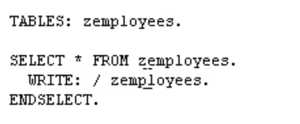

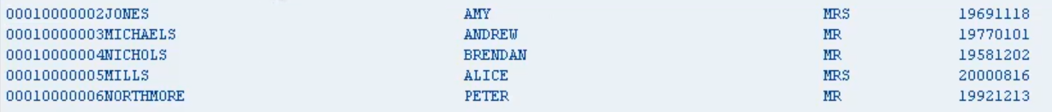

And the select statement allows us to iterate through a record set.

Now I did mention how our iteration statements come in two forms, those with conditions and those without.

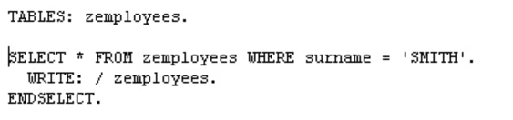



let's extend the first line of the select statement to say where surname equals Smith. So now when the select statement executes, it will only select records where the surname is Smith and output them to the screen.